**Project Design Phase**

**Solution Architecture**

|  |  |
| --- | --- |
| Date | 15 February 2025 |
| Team ID | SWTID1743696165 |
| Project Name | Bookie Nest: Book management website |
| Maximum Marks | 4 Marks |

**Solution Architecture:**

The solution architecture for **Bookie Nest** plays a crucial role in bridging the gap between user needs and the technical implementation of the online book store. It involves several interconnected processes that ensure the platform delivers a seamless and scalable user experience. Its core objectives are to:

* Identify the most effective technological approach to meet the requirements of an online bookstore.
* Clearly outline the system's structure, features, user behavior flows, and technical interactions to all project stakeholders.
* Define the platform's core functionalities, development stages, and technical specifications.
* Establish a clear set of guidelines and requirements under which the Bookie Nest platform is developed, maintained, and deployed.

**Example - Solution Architecture Diagram:**

1. User Perspective Workflow

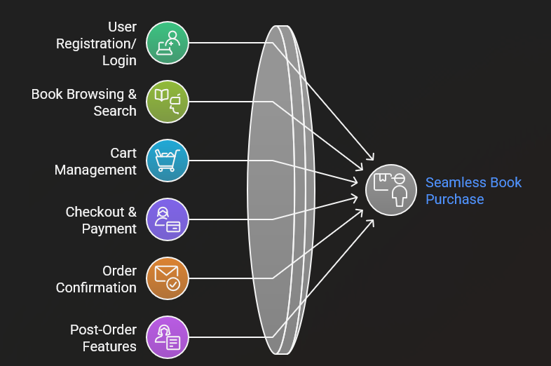

Figure 1: Architecture and data flow of user side application

2. Admin Perspective Workflow

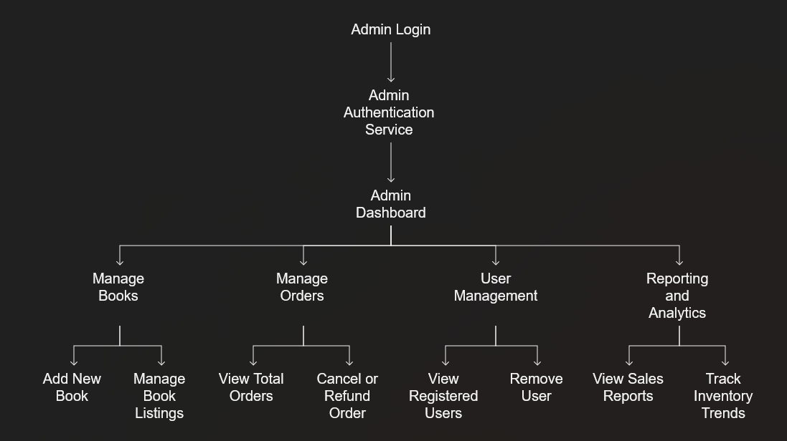

Figure 2: Architecture and data flow of admin side application